

# 

### Semester One Examination, 2020

### Question/Answer booklet

# MATHEMATICS

**SOLUTIONS**

**METHODS**

**UNIT 3**

## Section One:

## Calculator-free

|  |  |  |  |  |  |  |  |  |  |  |
| --- | --- | --- | --- | --- | --- | --- | --- | --- | --- | --- |
| WA student number: In figures |  |  |  |  |  |  |  |  |  |  |

In words

Your name

|  |  |
| --- | --- |
| Number of additional answer booklets used (if applicable): |  |

## Time allowed for this section

Reading time before commencing work: five minutes

Working time: fifty minutes

## Materials required/recommended for this section

***To be provided by the supervisor***

This Question/Answer booklet

Formula sheet

***To be provided by the candidate***

Standard items: pens (blue/black preferred), pencils (including coloured), sharpener,  
correction fluid/tape, eraser, ruler, highlighters

Special items: nil

## Important note to candidates

No other items may be taken into the examination room. It is **your** responsibility to ensure that you do not have any unauthorised material. If you have any unauthorised material with you, hand it to the supervisor **before** reading any further.

## Structure of this paper

|  |  |  |  |  |  |
| --- | --- | --- | --- | --- | --- |
| Section | Number of questions available | Number of questions to be answered | Working time (minutes) | Marks available | Percentage of examination |
| Section One: Calculator-free | 8 | 8 | 50 | 52 | 35 |
| Section Two: Calculator-assumed | 13 | 13 | 100 | 98 | 65 |
|  | | |  | **Total** | 100 |

General comments for Calculator free section:

* It is clear that when students are practicing and doing class exercises that they are saying “close enough is good enough” As such they do not have the rigour or setting out that is acceptable in an assessment. It is this lack of finishing properly, introducing a process in the middle and the lack of clear and logical working that may incur penalties. If you make an arithmetic error, and there is no logic for the marker to follow - you will lose all marks rather than 1 at the point of error. This is NOT a skill you can pull out of your hat in an assessment – practice this EVERYtime you do a question. Look carefully at the setting out in the solutions…is yours as good? If not FIX it and practice it.
* And let’s talk about arithmetic errors…there are WAY too many careless errors – (here are some examples: 8x8=16, 8x8=81, 5x5=5…..etc..) each one will carry a penalty and can be very costly. If time was an issue, this is understandable, but it there was plenty of time to check – then recalculate – this was especially evident in definite integrals with fractions. At your level we expect you to be able to do simple fractions and to keep track of negative signs!!!!
* Don’t half differentiate a function in one line and finish differentiating it in the other line….this is incorrect.

Section One: Calculator-free 35% (52 Marks)

This section has**eight** questions. Answer **all** questions. Write your answers in the spaces provided.

Working time: 50 minutes.

Question 1 (5 marks)

Determine the area bounded by the line $y=-2x$ and the parabola $y=x^{2}-6x$.

|  |
| --- |
| **Solution** |
| Intersect when $$-2x-\left(x^{2}-6x\right)=0 \\ 4x-x^{2}=0 \\ x\left(4-x\right)=0 \\ x=0, 4$$ Bounded area $$A=\int_{0}^{4}{4x-x^{2}}dx \\ ={\left[2x^{2}-\frac{x^{3}}{3}\right]}_{0}^{4} \\ =\left(32-\frac{64}{3}\right)-(0) \\ =32-21.\overline{3} \\ =10.\overline{6}=10\frac{2}{3} \text{square units}$$ |
| **Specific behaviours** |
| ✓ equates functions, simplifies and solves.  ✓ correct order or correct use of ||  ✓ antidifferentiates  ✓ substitutes correctly  ✓ follow through area (-1 if no units2) |

)

I find it hard to believe how badly done this question was. The marksbreakdown said there was an area question in CF – so you should have practiced doing this by hand – at least a few times. The arithmetic errors were unbelievable!!! Students who thought that they could do $\int_{0}^{4}{\left|4x-x^{2}\right|}dx$ without a calculator!

Common error:

$-2x=\left(x^{2}-6x\right)⇒4x=x^{2}⇒x=4‼‼$

$REALLY??‼! I thought we sorted this out LAST year‼!$

* The higher function was clearly unknown, !!! For this question you either had to draw a sketch or find the integral, knowing that if it was negative that you needed the positive (absolute value). It is OK to get a negative integral and then say $∴the area= \left|-10\frac{2}{3}\right|=10\frac{2}{3} {units}^{2}$ what is NOT OK is to just “misplace” the negative whilst still using the = sign.

Too many times students did it the wrong way around then tried to fudge their solutions. Did you think we wouldn’t read your working? – this then became 2 mistakes

Question 2 (5 marks)

A curve, defined for $x>0$, passes through the point $P(2, 3)$ and its gradient is given by

$$\frac{dy}{dx}=6x^{2}-\frac{4}{x^{2}}-23$$

(a) Verify that $P$ is a stationary point, determine the value of the second derivative at $P$ and hence describe the nature of the stationary point. (3 marks)

|  |
| --- |
| **Solution** |
| $$f^{'}\left(x\right)=6x^{2}-\frac{4}{x^{2}}-23⇒f^{'}\left(2\right)=24-1-23=0$$ $f^{'}\left(2\right)=0$, so $P$ is a stationary point. $$f^{''}\left(x\right)=12x+\frac{8}{x^{3}}⇒f^{''}\left(2\right)=24+1=25$$ $f^{''}\left(2\right)>0$, so $P$ is a local minimum. |
| **Specific behaviours** |
| ✓ simplifies $f'(2)$ to three integers that sum to zero  ✓ correct value of second derivative  ✓ states correct nature |

The key word here was VERIFY – that means show it….no shortcuts. It is NOT enough to say f’(x) = 0 so x =2, unless you actually did it (which of course is NOT the way to do this question – easy way is shown above). Find f”(2) don’t just say it is positive – again this is a process. This is a LOCAL minimum. I did not penalise either of these things but the next marker probably will.

(b) Determine the equation of the curve. (2 marks)

|  |
| --- |
| **Solution** |
| $$f\left(x\right)={2x}^{3}+\frac{4}{x}-23x+c$$ $$f\left(2\right)=16+2-46+c=3⇒c=31$$ $$y=2x^{3}+\frac{4}{x}-23x+31$$ |
| **Specific behaviours** |
| ✓ correct antiderivative  ✓ evaluates constant and writes equation |

A number of students misread this to mean the equation of the tangent – then tried to find one. Read the question – highlight requirements. Most people who DID do this did it well. Those who still can’t integrate this function, then find the constant of integration, should seriously think about why they are doing this course.

Question 3 (7 marks)

A bag contains $40$ counters, $15$ marked with $0$ and the remainder marked with $1$. The random variable $X$ is the number on a randomly selected counter from the bag.

(a) Explain why $X$ is a Bernoulli random variable and determine the mean and variance of $X$.

(3 marks)

|  |
| --- |
| **Solution** |
| $X$ is a Bernoulli random variable as it can only take on two values, $0$ and $1$. $$E\left(X\right)=p=\frac{40-15}{40}=\frac{5}{8}$$ $$σ^{2}=\frac{5}{8}×\frac{3}{8}=\frac{15}{64}$$ |
| **Specific behaviours** |
| ✓ states $X$ can only take on two values  ✓ mean  ✓ variance |

Each of the $32$ students in a class randomly select a counter from the bag, note the number on the counter and then replace it back in the bag. The random variable $Y$ is the number of students in the class who select a counter marked with $0$.

(b) Define the distribution of $Y$ and determine the mean and variance of $Y$. (3 marks)

|  |
| --- |
| **Solution** |
| $$Y\sim B\left(32,\frac{3}{8}\right)$$ $$E\left(Y\right)=np=32×\frac{3}{8}=12$$ $$σ^{2}=12×\frac{5}{8}=\frac{15}{2}=7.5$$ |
| **Specific behaviours** |
| ✓ states binomial with parameters  ✓ mean  ✓ variance |

(c) Explain why it is important that the students replace their counters for the distribution of $Y$ in part (b) to be valid. (1 mark)

|  |
| --- |
| **Solution** |
| If counters not replaced, the probability of a success (selecting a counter marked with $0$) would not remain constant. |
| **Specific behaviours** |
| ✓ indicates that probability of success must be constant |

This was generally well done. The mistakes were as a result of poor arithmetic skills when multiplying fractions (i.e. not simplifying them first – unsimplified answers get full marks but ones stated as a product incur penalty)

(c) I was generous but the explanations were just not precise enough. The best: “because replacing counters means that each trial is independent, so the probabilities remained constant”

The worse were:

“so it (whatever it is) remains constant”…. “ if they didn’t it wouldn’t be binomial” (WHY??)…. “because n will change each time”(AND that means what???) “otherwise it would affect the probability (And that’s a problem because????)

Question 4 (8 marks)

Determine

(a) $f'(x)$ when $f\left(x\right)=\sqrt{4x-3}$. (2 marks)

|  |
| --- |
| **Solution** |
| $$f^{'}\left(x\right)=\frac{1}{2}(4){\left(4x-3\right)}^{-\frac{1}{2}} \\ =\frac{2}{\sqrt{4x-3}}$$ |
| **Specific behaviours** |
| ✓ indicates correct use of chain rule  ✓ correct derivative (any form) |

(b) $\begin{matrix}d \\ \overline{dθ}\end{matrix}\left(θ^{3}e^{4θ}\right)$ when $θ=2$. (3 marks)

|  |
| --- |
| **Solution** |
|  |
| **Specific behaviours** |
| ✓ ✓ correct derivative in terms of $θ$ ✓ correct value |

(c) $f^{'}\left(\frac{π}{4}\right)$ when $f\left(t\right)=\begin{matrix}1+\cos{t} \\ \overline{ \sin{t} }\end{matrix}$. (3 marks)

|  |
| --- |
| **Solution** |
| $$f^{'}\left(t\right)=\frac{-\sin{t}⋅\sin{t}-\left(1+\cos{t}\right)⋅\cos{t}}{\sin^{2}{t}} \\ =\frac{-\cos{t}-\sin^{2}{t}-\cos^{2}{t}}{\sin^{2}{t}} \\ =\frac{-1-\cos{t}}{\sin^{2}{t}}$$ $$f^{'}\left(\frac{π}{4}\right)=\left(-1-\frac{1}{\sqrt{2}}\right)÷\frac{1}{2} \\ =-2-\sqrt{2}$$ |
| **Specific behaviours** |
| ✓ ✓ correct derivative  ✓ correct value, simplified |

This question was fairly well done as far as the derivatives were concerned (as so they should be) The problem was with the substitution and simplification of answers.

(b) was Ok but I noticed a really poor use of notation again. $3θ^{2}e^{4θ}$ does not equal $12e^{8}$– it just DOESn’t…indicate that you are substituting in a value. Again I did not penalise this – but it doesn’t mean you are correct.

(c) was pretty poor. Lucky for you this was only worth 1 mark – which was often lost.

Question 5 (7 marks)

Functions $f$ and $g$ are such that

$$f\left(4\right)=2, f^{'}\left(x\right)=18{\left(3x-10\right)}^{-2}$$

$$g\left(-4\right)=2, g^{'}\left(x\right)=18{\left(3x+10\right)}^{-2}$$

(a) Determine $f(6)$. (3 marks)

|  |
| --- |
| **Alternate Solution** |
| $$\int{18{\left(3x-10\right)}^{-2}dx}=\frac{-6}{3x-10}+c$$ $$f\left(4\right)=2 so 2 = \frac{-6}{2}+c ⇒c=5 \\ f\left(x\right)=\frac{-6}{3x-10}+5$$ $$f\left(6\right)=\frac{-6}{8}+5=4\frac{1}{4}$$ |
| **Specific behaviours** |
| ✓ integrates  ✓ determines c  ✓ correct value of f(6) |

|  |
| --- |
| **Solution** |
| $$f\left(6\right)=f\left(4\right)+\int_{4}^{6}{18{\left(3x-10\right)}^{-2}}dx \\ =2+{\left[\frac{-6}{3x-10}\right]}_{4}^{6} \\ =2+\left(-\frac{3}{4}-(-3)\right) \\ =\frac{17}{4}=4\frac{1}{4}$$ |
| **Specific behaviours** |
| ✓ integrates rate of change  ✓ determines change  ✓ correct value |

(b) Use the increments formula to determine an approximation for $g(-3.98)$. (3 marks)

|  |
| --- |
| **Solution** |
| $$x=-4, δx=0.02$$ $$δy≈\frac{18}{{\left(3x+10\right)}^{2}}×δx \\ ≈\frac{18}{4}×0.02≈0.09$$ $$g\left(-3.98\right)≈2+0.09≈2.09$$ |
| **Specific behaviours** |
| ✓ values of $x$ and $δx$ ✓ use of increments formula  ✓ correct approximation |

(c) Briefly discuss whether using the information given about $f$ and the increments formula would yield a reasonable approximation for $f(6)$. (1 mark)

|  |
| --- |
| **Solution** |
| No, approximation wouldn't - the change $δx=2$ is not a small change. |
| **Specific behaviours** |
| ✓ states no with correct reason |

This question was reasonably done. 99% of students used 2nd method for (a) and although more work, most did correctly although once again too many arithmetic errors.

(b) was actually not badly done although many students did not find the approximation.

(c) very well done.

Question 6 (5 marks)

The graph of $y=f(x)$ has a stationary point at $(-1, 2)$ and $f^{'}\left(x\right)=ax^{2}+4x+6$, where $a$ is a constant.

Determine the interval over which $f^{'}\left(x\right)>0$ and $f^{''}\left(x\right)<0$.

|  |
| --- |
| **Solution** |
| $$f^{'}\left(-1\right)=a-4+6=0 \\ a=-2$$ Concave down: $$f^{'}\left(x\right)=-2x^{2}+4x+6 \\ f^{''}\left(x\right)=-4x+4 \\ f^{''}\left(x\right)<0⇒x>1$$ Other stationary point: $$-2x^{2}+4x+6=0 \\ -2\left(x+1\right)\left(x-3\right)=0 \\ x=3$$ Hence $f^{'}\left(x\right)>0$ when $-1<x<3$.  Required interval: $1<x<3$. |
| **Specific behaviours** |
| ✓ value of $a$ ✓ interval where $f^{''}\left(x\right)<0$ ✓ second stationary point  ✓ interval where $f^{'}\left(x\right)>0$ ✓ correct interval |

|  |
| --- |
| **How I would have done it** |
| $$f^{'}\left(-1\right)=a-4+6=0 \\ a=-2$$ $$i.e.-2x^{2}+4x+6=0 \\ -2\left(x+1\right)\left(x-3\right)=0 \\ x=-1 or x=3$$ So from here I would have sketched the graph of $y=f’(x)$ Hence $f^{'}\left(x\right)>0$ when $-1<x<3$. $$f^{''}\left(x\right)<0 (graph decreasing)⇒x>1$$ So BOTH:  Required interval: $1<x<3$. |
|  |
| **Specific behaviours** |
| ✓ value of $a$ ✓ solve  ✓ interval where $f^{''}\left(x\right)<0$ ✓ interval where $f^{'}\left(x\right)>0$ ✓ correct interval |

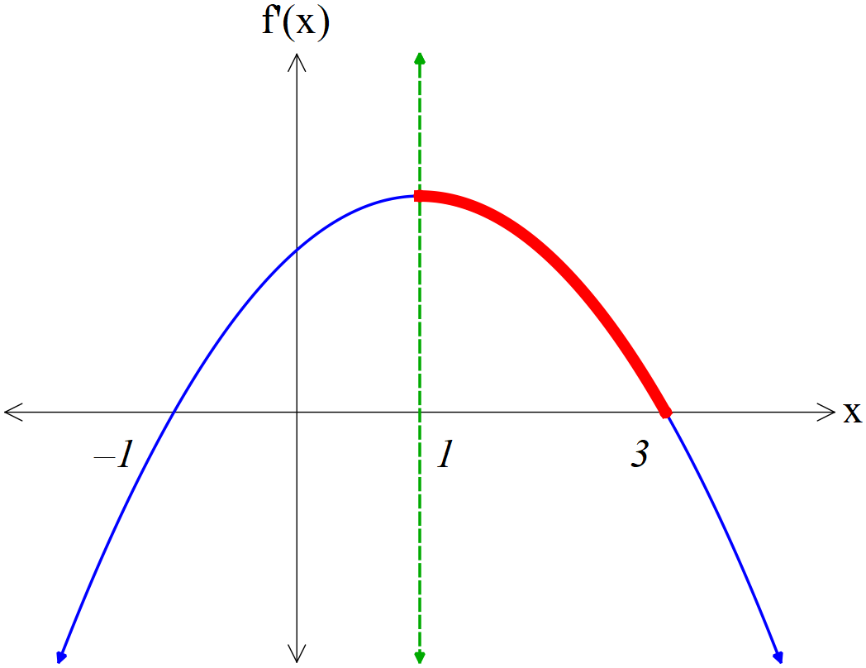

This was not done well. The students who were on the right track often made too many mistakes to get there. Many students could not even make a start, the 2 methods above are not the only ways to do this. A number of students did all the work, but did not complete it by stating the interval where the BOTH conditions were met.

Question 7 (8 marks)

Initially, particle $P$ is stationary and at the origin. Particle $P$ moves in a straight line so that at time $t$ seconds its acceleration cms-2 is given by $a=8-3\sqrt{t}$ where $t≥0$.

(a) Determine the speed of $P$ after $1$ second. (3 marks)

|  |
| --- |
| **Solution** |
| $$v=\int{8-3t^{0.5}}dt \\ =8t-2t^{1.5}+c \\ v\left(0\right)=0⇒c=0 \\ v=8t-2t^{1.5}$$ $$v\left(1\right)=8\left(1\right)-2{\left(1\right)}^{1.5}=6$$ Hence speed is $6$ cm/s. |
| **Specific behaviours** |
| ✓ indicates $v$ is integral of  ✓ expression for velocity $v$ with c explained  ✓ correct speed, with units |

(b) Determine the speed of $P$ when it returns to the origin. (5 marks)

|  |
| --- |
| **Solution** |
| Require $0$ change in displacement for $0≤t≤T$ $$Δx=\int_{0}^{T}{8t-2t^{1.5}}dt \\ 0={\left[4t^{2}-\frac{4}{5}t^{2.5}\right]}_{0}^{T} \\ 4T^{2}-\frac{4}{5}T^{2.5}=0 \\ 4T^{2}\left(1-\frac{1}{5}\sqrt{T}\right)=0 \\ \sqrt{T}=5 \\ T=25$$ $$v\left(25\right)=8\left(25\right)-2{\left(25\right)}^{\frac{3}{2}} \\ =200-250=-50$$ Hence speed is $50$ cm/s. |
| **Specific behaviours** |
| ✓ obtains expression for $Δx$ in terms of $T$ ✓ ✓ equates $Δx=0$ and solves for $T$ ✓ obtains velocity  ✓ correct speed, with units |

|  |
| --- |
| **Slightly different Solution** |
| $$x\left(t\right)=4t^{2}-\frac{4}{5}t^{2.5}+k$$ $$x\left(0\right)=0 ∴k=0$$ $$x\left(t\right)=0⇒4t^{2}-\frac{4}{5}t^{2.5}=0 \\ 4t^{2}\left(1-\frac{1}{5}\sqrt{t}\right)=0 \\ t=0, \sqrt{t}=5 \\ t=25$$ $$v\left(25\right)=8\left(25\right)-2{\left(25\right)}^{\frac{3}{2}} \\ =200-2{\left(5\right)}^{3} \\ =200-250=-50cm/s$$ Hence speed is $50$ cm/s. |
| **Specific behaviours** |
| ✓ obtains expression for $x\left(t\right), equating constant.$ ✓ ✓ equates $Δx=0$ and solves for $T$ ✓ obtains velocity  ✓ correct states speed, with units |

Firstly, If you are going to use the second method and you have 2 constants of integration, name them differently c and k or c1 and c2.

Secondly – read the question – the units were cm/s…a sad loss of a mark…yes kick yourself!!!

As it wanted speed and you found velocity…STATE the speed.

Students who got off the ground with this one, kind of followed a correct method – until it came to solving $4t^{2}-\frac{4}{5}t^{2.5}=0$…oh the horror!!!! Remember $t^{2.5}= t^{2}×t^{0.5}$ so….

$$t^{2}\left(4-\frac{4}{5}t^{0.5}\right)=0 ⇒ 4=\frac{4}{5}\sqrt{t} ⇒ 5= \sqrt{t} and here's the kicker so t=25 not \sqrt{5}$$

And then you had to substitute it into the velocity: ${\left(25\right)}^{\frac{3}{2}} no do not do \sqrt{{25}^{3}} by hand…simplfy index i.e. 25 is 5^{2}, the square root is the$

$$power of a half so 5^{2×3×0.5}=5^{3}=125$$

Question 8 (7 marks)

(a) Determine an expression for $\begin{matrix}d \\ \overline{dt}\end{matrix}\left(6t\cos\left(\begin{matrix}πt \\ \overline{ 6 }\end{matrix}\right)\right)$. (2 marks)

|  |
| --- |
| **Solution** |
| $$\frac{d}{dt}\left(6t\cos\left(\frac{πt}{6}\right)\right)=6\cos\left(\frac{πt}{6}\right)-πt\sin\left(\frac{πt}{6}\right)$$ |
| **Specific behaviours** |
| ✓ correct use of product rule  ✓ correct derivative |

The volume of water in a tank, $v$ litres, is changing at a rate given by $v'(t)=πt\sin\left(\begin{matrix}πt \\ \overline{ 6 }\end{matrix}\right)$, where $t$ is the time in hours. The rate of change is shown in the graph below.

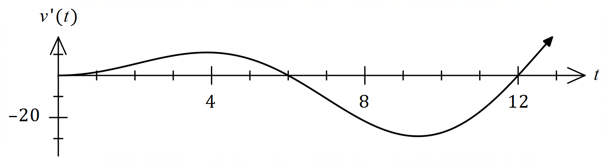

(b) Using the result from part (a) or otherwise, determine the change in volume of water in the tank between $t=0$ and $t=12$ hours. (5 marks)

|  |
| --- |
| **Solution** |
| $$Δv=\int_{0}^{12}{v'(t)}dt=\int_{0}^{12}{πt\sin\left(\frac{πt}{6}\right)dt}$$ 1. Using (a): $$\int{\frac{d}{dt}\left(6t\cos\left(\frac{πt}{6}\right)\right)}dt=\int{6\cos\left(\frac{πt}{6}\right)}dt-\int{πt\sin\left(\frac{πt}{6}\right)}dt$$ 2. And so: $$\int{πt\sin\left(\frac{πt}{6}\right)}dt=\int{6\cos\left(\frac{πt}{6}\right)}dt-6t\cos\left(\frac{πt}{6}\right)$$ 3. Hence: $$\int_{0}^{12}{πt\sin\left(\frac{πt}{6}\right)dt}={\left[\frac{36}{π}\sin\left(\frac{πt}{6}\right)\right]}_{0}^{12}-{\left[6t\cos\left(\frac{πt}{6}\right)\right]}_{0}^{12} \\ =\left[0-0\right]-\left[72-0\right] \\ Δv=-72 \text{L}$$ |
| **Specific behaviours** |
| ✓ indicates required definite integral  ✓ line 1 - uses part (a)  ✓ line 2 - expression to evaluate integral  ✓ line 3 - antidifferentiates ready for substitution  ✓ correct change in volume, with units |

(a) in this was really rather well done, and if it wasn’t (b) just fell apart and it was very hard to get any marks as students made the question easier. Too many students just igbnored one of the integrals – this cannot gain marks – the correct answer with incorrect working just doesn’t get you anything. This is a pretty standard ‘tough’ question – learn it. One thing that I noticed was people ignoring the order of integration. i.e. $\int_{a}^{b}{f\left(x\right)dx=F\left(b\right)-F\left(a\right) NOT F\left(a\right)-F\left(b\right) }$ and yes that DOES make a difference.

Very few students did this in a clear and logical way showing the logical steps..as I said LEARN IT.

Supplementary page

Question number: _________